SOME IMPORTED ITEMS PICTURE
Product Name | Product Picture | Country of Origin
Lightening Arrestor (LA) | 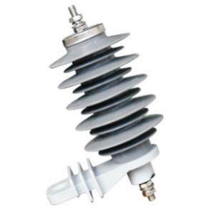 | SPAIN (EU)
Dropout Fuse Cutout (DOFC) | 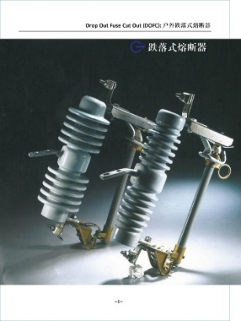 | SPAIN (EU)
MCCB | 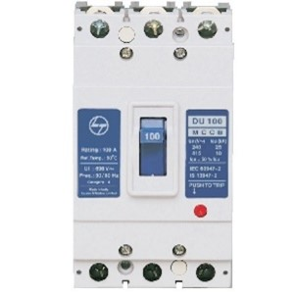 | TURKEY
PIN Insulator | 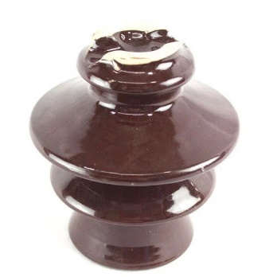 | CHINA
Line Post Insulator | 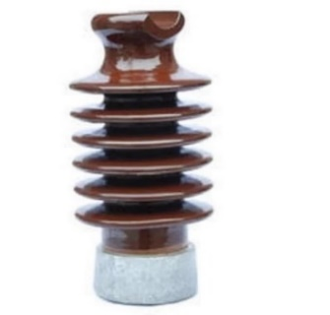 | CHINA
DISC Insulator | 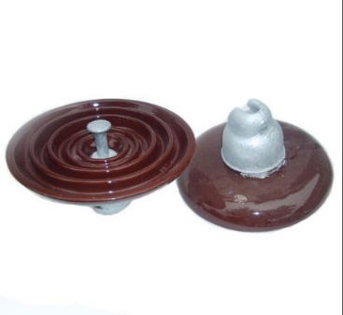 | CHINA
Thermal Imaging Camera | 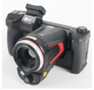 | POLAND
Temperature Gun | 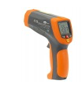 | POLAND
Relay | 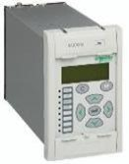 | UK & FRANCE (EU)
AVO Meter | 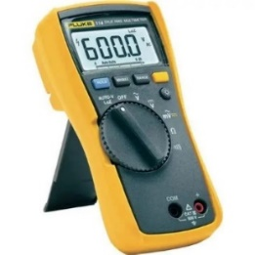 | JAPAN
PIN Insulator Fittings | 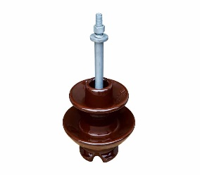 | INDIA
DISC Insulator Fittings | 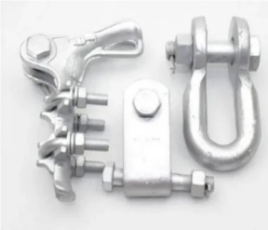 | INDIA
Conductor Accessories | 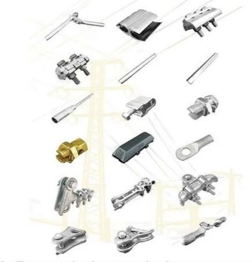 | INDIA

